

Project Management Plan

**Version1.5**

**Quốc Nhân**

**09/11/2019**

**VERSION HISTORY**

|  |  |  |  |  |  |
| --- | --- | --- | --- | --- | --- |
| **Version #** | **Implemented**  **By** | **Revision**  **Date** | **Approved**  **By** | **Approval**  **Date** | **Reason** |
| 1.0 | Quốc Nhân | 30/10/2019 |  |  | Create Document version 1.0 |
| 1.1 | Quốc Nhân | 31/10/2019 |  |  | Edit Document version 1.1 |
| 1.2 | Quốc Nhân | 1/11/2019 |  |  | Edit Document version 1.2 |
| 1.3 | Quốc Nhân | 4/11/2019 |  |  | Update Milestone v1.3 |
| 1.4 | Quang Vương | 09/11/2019 | Team | 09/11/2019 | Team review and update |
| 1.5 | Quốc Nhân | 12/11/2019 |  |  | Update content scope v1.5 |

Table of Contents

1. Introduction 3

2. Purpose 3

3. Scope And RESTRICTIONS 3

3.1 Scope 3

3.2 Limit and difficult 3

**4.** **COMMERCIAL CONTEXTS 8**

4.1 Priority 8

4.2 Environment Operating 8

4.3 Milestone 8

4.4 Risk Plant 9

**5.** **PLANNING AND ACCESSING THE PROJECT 9**

5.1 Process 9

5.2 Role and Responsibility 10

**6.** **PRODUCT 10**

**7.** **SCHEDULE 10**

**8.** **RISK MANAGE 10**

**9.** **COMMUNICATE PLAN 10**

**10.** **CONFIGURATION PLAN 10**

# 

# Introduction

Today, information technology is developing day by day. Convenience companies are also mushrooming like app grabs on traffic, app now on food, so housing is an important issue. important to people today. The introduction of real estate management application will solve current problems for everyone.

- App real estate is an internal tool that can interact with each other

- Help managers easily control the information.

- App also helps customers get the necessary information about a land.

# Purpose

The objective of the document is to describe the workflow, schedule, functions and problems of the real estate project.

# Scope

## Scope

|  |  |  |  |
| --- | --- | --- | --- |
| **ID** | **FUNCTION** | **DESCRIPTION** | **CLASSIFY** |
| **Account management** | | | |
| FR.01 | Login | Users are provided accounts from the admin | Employees, department head, leader and administrator |
| FR.02 | Logout |
| FR.03 | Display account information |  | administrator |
| FR.04 | Search for personnel | Users can search for personnel | Employees, department head, leader and administrator |
| FR.05 | Display personnel list |  | administrator |
| FR.06 | Show company chart |
| FR.07 | Display company policies |
| FR.08 | Add accounts | Admin add new user | Administrator |
| FR.09 | Delete accounts | Admin the delete of users from the system |
| FR.10 | Edit accounts | Admin the editing of user information |
| FR.11 | Accounts classification | Admin the accounts classification of users from the system |
| **Project management** | | | |
| FR.12 | Show project list |  | Administrator |
| FR.13 | Search for the project | Users can search for the project | Employees, department head, leader and administrator |
| FR.14 | Show project details |  | Administrator |
| FR.15 | Add project |
| FR.16 | Edit project |
| FR.17 | Project classification |
| **Statistical management, reporting** | | | |
| FR.18 | Displaying business results | After the admin receives statistical information, reports from the company, the admin will display on the app | Administrator |
| FR.19 | Displaying business results graph |
| FR.20 | Display table comparing business results |
| **Business trip manager** | | | |
| FR.21 | Sign up for business trip | Staff, leader and department head will register the business trip | Employees, leader and department head |
| FR.22 | Browse business trip | The manager will confirm | Leaders, departments head |
| FR.23 | Business trip history | Entire company can review history | Internal members in the company |
| **Management quit** | | | |
| FR.24 | Register to quit your job | Staff, leader and department head will register the day off | Employees, leader and department head |
| FR.25 | Approval of leave | The manager will review and approve the leave | Leaders, department head |
| FR.26 | History of leave | Entire company can review history | Internal members in the company |
| **Other functions** | | | |
| FR.27 | Birthday staff notification | The app will display a happy birthday notification for everyone (on staff's birthday). | System (popup) |

## Limit and Difficult

* Need time to train staff, use instructions.
* The system does not work without the Internet.

# Commercial contexts

## Priority

|  |  |
| --- | --- |
| **Requirets** | **Priority** |
| Account management | High |
| Project management | High |
| Statistical management, reporting | High |
| Business trip manager | High |
| Management quit | High |
| Other functions | Low |

## Environment Operating

* Android studio
* React native
* Visual Studio Code

## Milestone

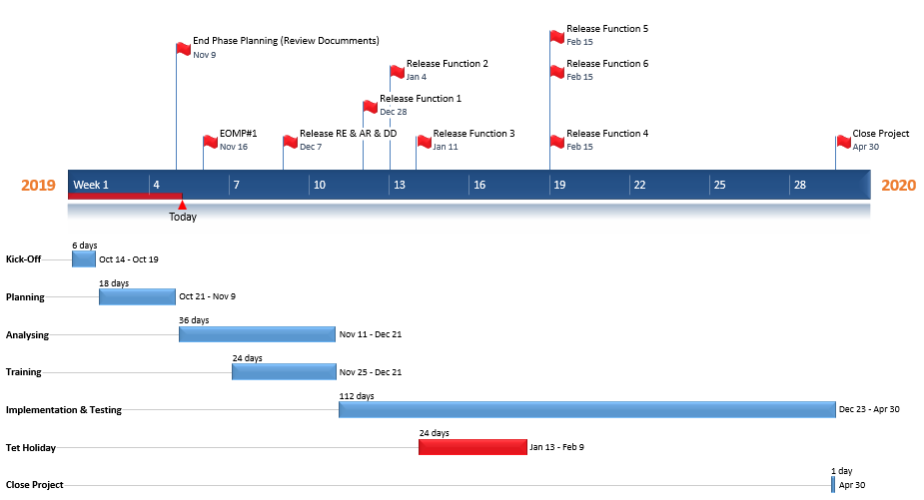

## Risk

* Not familiar with the tools used in the project (GIS, Android, IOS)
* Not knowing about the operation of a real estate project
* Not proficient in programming languages ​​and map systems (Android, IOS)
* Due to lack of practical experience of real estate project

1. **Planning and accessing the projects**

## Process

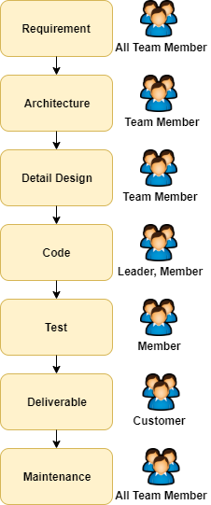

## Role and Responsibility

|  |  |
| --- | --- |
| **Role** | **Responsibility** |
| Mentor | Managing teamwork  Direct contact with stakeholders  Guide the team to the project |
| Project Team | Do & develop real estate projects |
| Customer | Guide business processes, tools  Approve the product |

1. **Product**

|  |  |
| --- | --- |
| **Product** | **Detail** |
| Package installation | Source Codes and Database |
| Installation instructions |
| User guide |
| Requirement Document | Concept of Operations |
| Software Requirement |
| Design Document | Architectural Driver |
| Architectural Design |
| Detail Design |
| Database Document | Database Design |

1. **Schedule**



**PM_WorkBreakdownStructure**

1. **Risk management**



**PM_RiskManagementPlan_Ver1.0**

1. **Communicate plan**



**PM_CommunicationPlan_Ver1.2**

1. **Configuration plan**



**PM_ConfigurationManagementPlan_Ver1.0**